**A**

**Project Report**

**is**

**Submitted to the completion of Epam-COE-DevOPS**

**Training Program**



**Submitted By:**

**Mr. Ankur Bhardwaj**

**Junior Software Engineer-Epam Hyderabad**

**PROJECT-1**

**Following is the documentation of project that covers following objectives:**

1. Three Tier web application using docker and Kubernetes
2. Configuration Management using Ansible (Roles)
3. Application code management using Git
4. Building CI/CD pipeline to deploy a new version of Application (Jenkins)
5. Building Monitoring for application
6. Login to AWS
7. Create Roles: jenkins-kubernetes-project

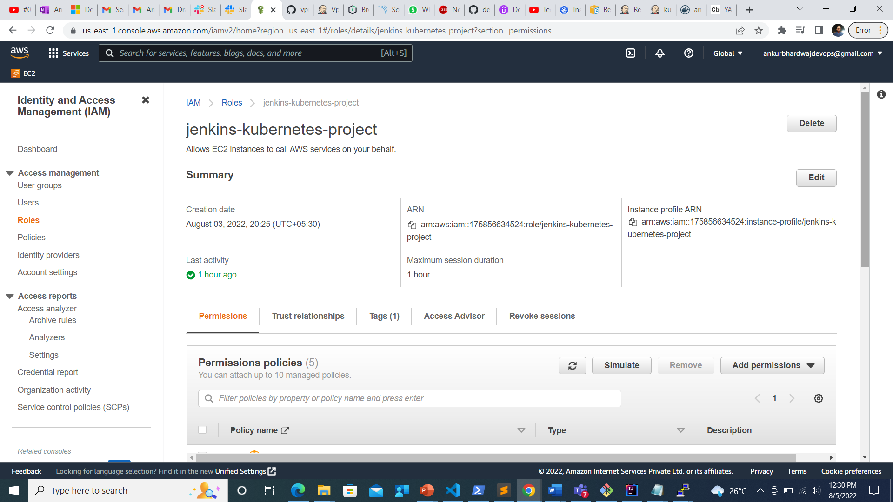

1. Assign policies to role

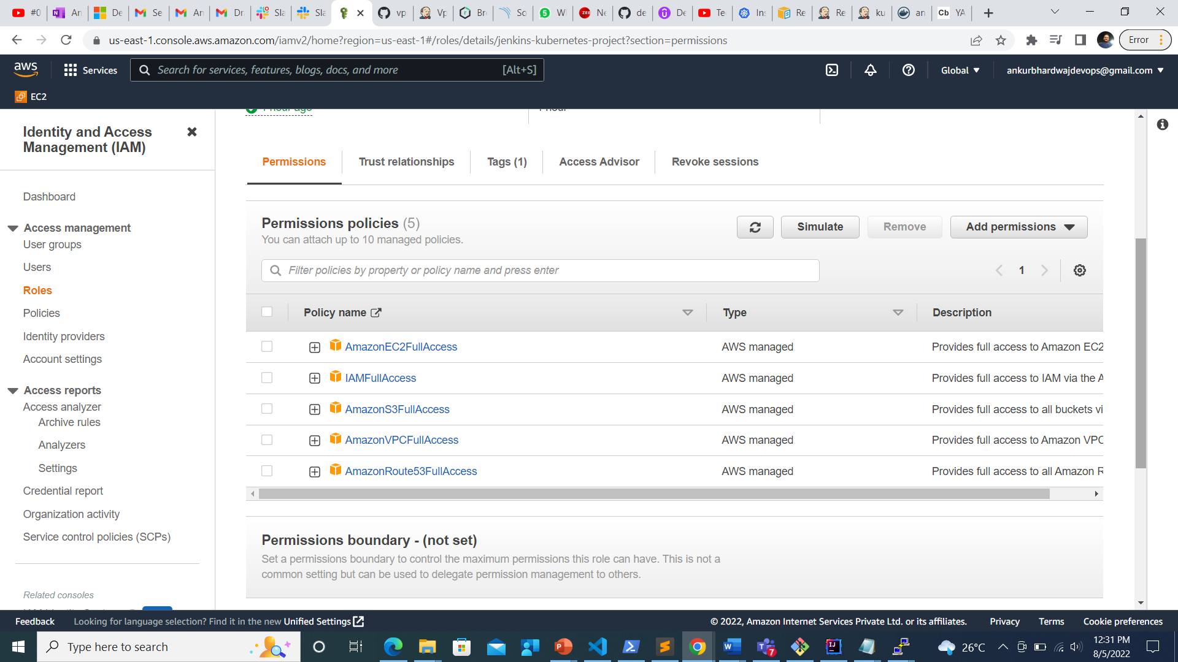

1. Create EC-2 instance
2. Named Controler-Machine
3. Consider a key-pair: controller

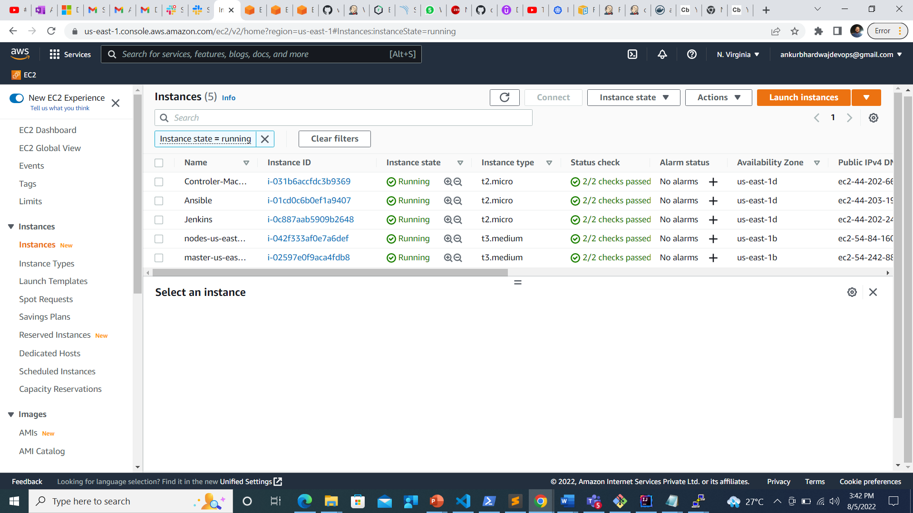

1. Connect it via Putty

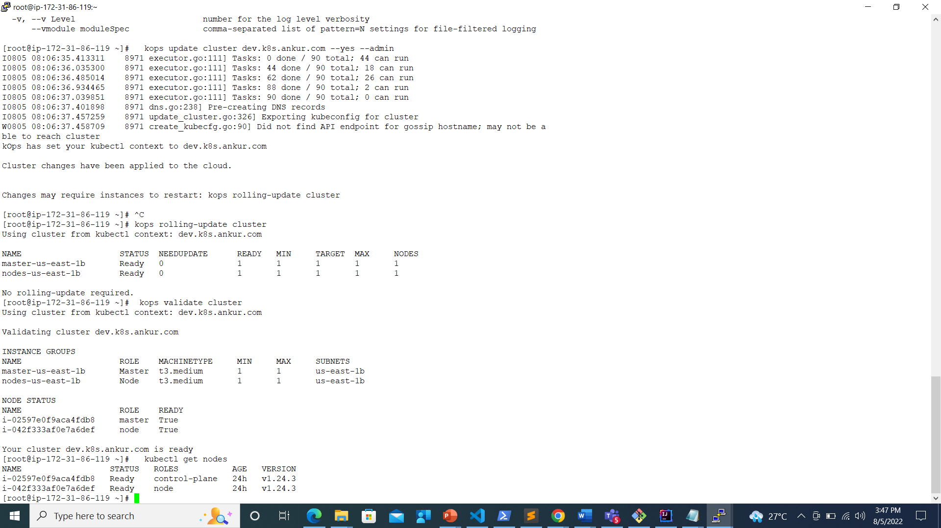

1. Installing Kubernetes using Kops

Refer the steps from this documentation:

[DevOpsDemos/k8s-setup.md at master · ValaxyTech/DevOpsDemos (github.com)](https://github.com/ValaxyTech/DevOpsDemos/blob/master/Kubernetes/k8s-setup.md)

1. Install kubectl
2. curl -LO https://storage.googleapis.com/kubernetes-release/release/$(curl -s https://storage.googleapis.com/kubernetes-release/release/stable.txt)/bin/linux/amd64/kubectl
3. chmod +x ./kubectl

sudo mv ./kubectl /usr/local/bin/kubectl

1. Create an IAM user/role with Route53, EC2, IAM and S3 full access
2. Attach IAM role to ubuntu server

**Note: If you create IAM user with programmatic access then provide Access keys.**

aws configure

1. Install kops on ubuntu instance:
2. curl -LO https://github.com/kubernetes/kops/releases/download/$(curl -s https://api.github.com/repos/kubernetes/kops/releases/latest | grep tag_name | cut -d '"' -f 4)/kops-linux-amd64
3. chmod +x kops-linux-amd64

sudo mv kops-linux-amd64 /usr/local/bin/kops

1. Create a Route53 private hosted zone (you can create Public hosted zone if you have a domain)
2. create an S3 bucket

aws s3 mb s3://dev.k8s.valaxy.in

1. Expose environment variable:

export KOPS_STATE_STORE=s3://dev.k8s.valaxy.in

1. Create sshkeys before creating cluster

ssh-keygen

1. Create kubernetes cluster definitions on S3 bucket

kops create cluster --cloud=aws --zones=ap-southeast-1b --name=dev.k8s.valaxy.in --dns-zone=valaxy.in --dns private

1. Create kubernetes cluser

kops update cluster dev.k8s.valaxy.in --yes

1. Validate your cluster

kops validate cluster

1. To list nodes

kubectl get nodes

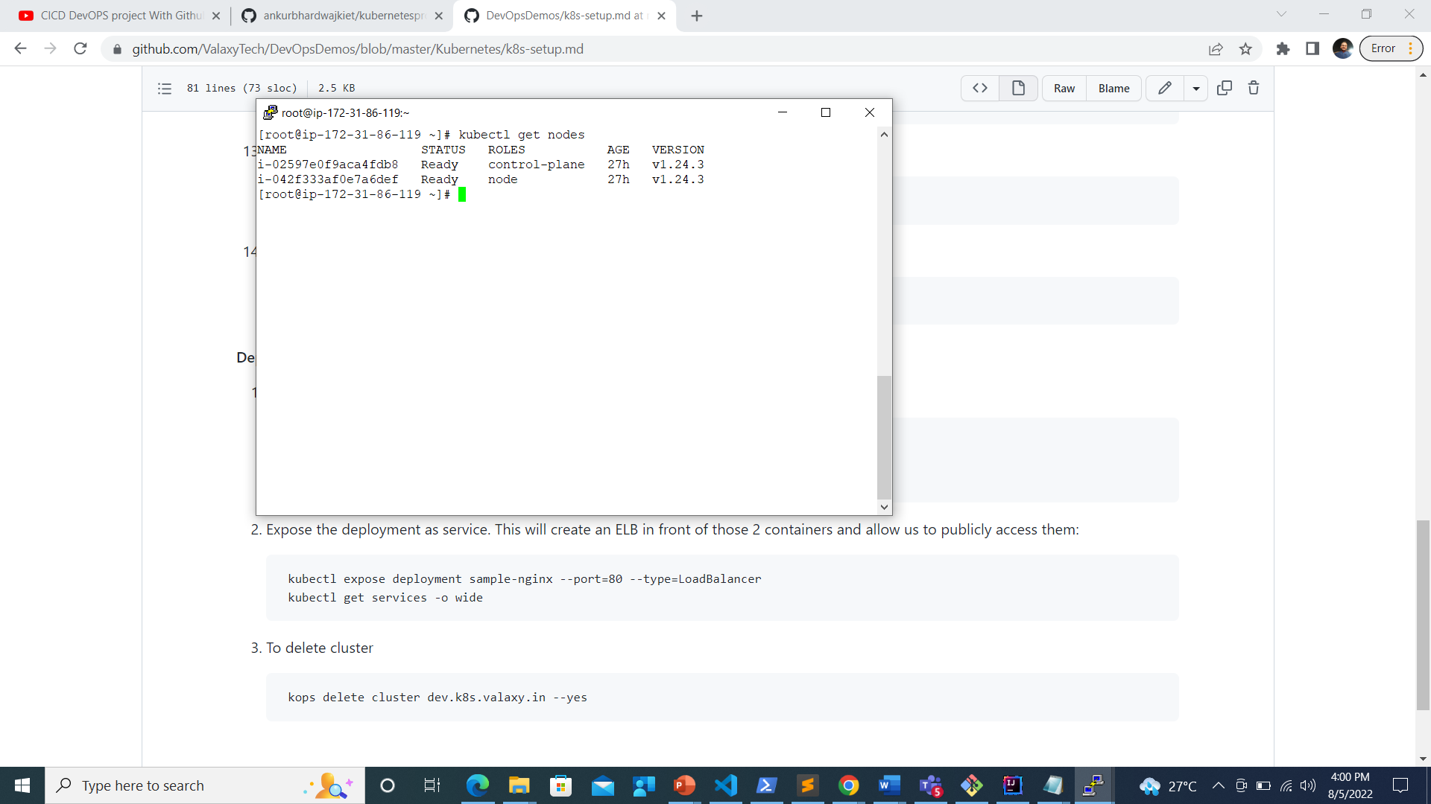

1. When the Cluster is UP.:
2. Master Node and worker node are created as EC-2 instance (Kubernetes cluster is created)

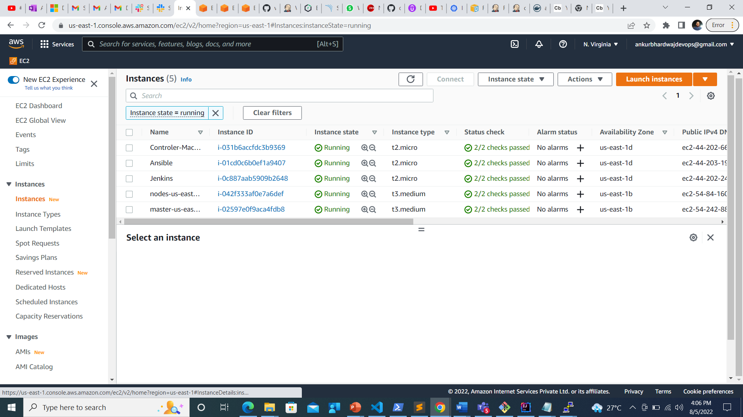

1. Now Create two more Instances:
2. Ansible
3. Jenkins

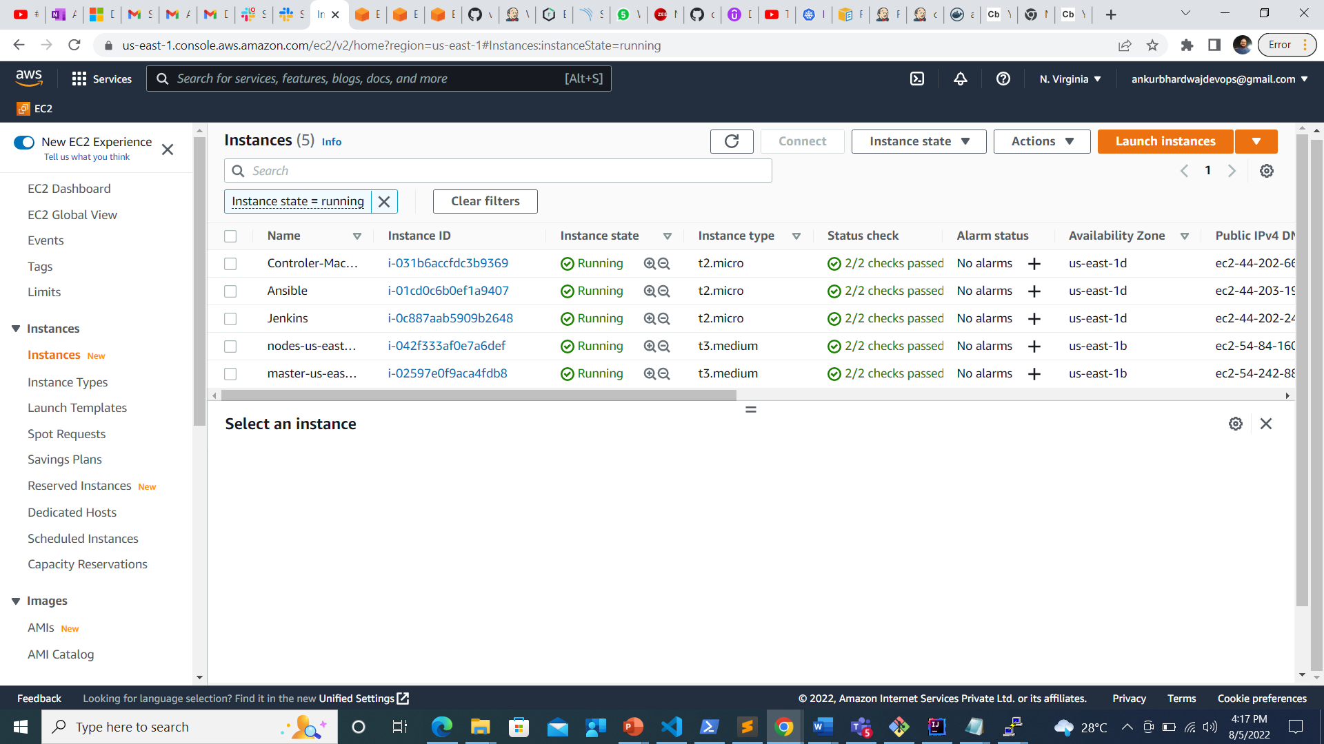

1. Jenkins Server

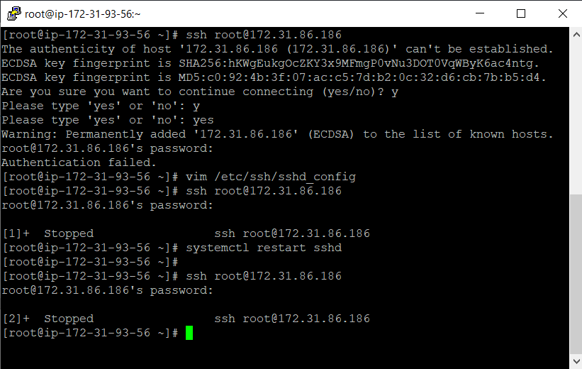

**Ansible Server**

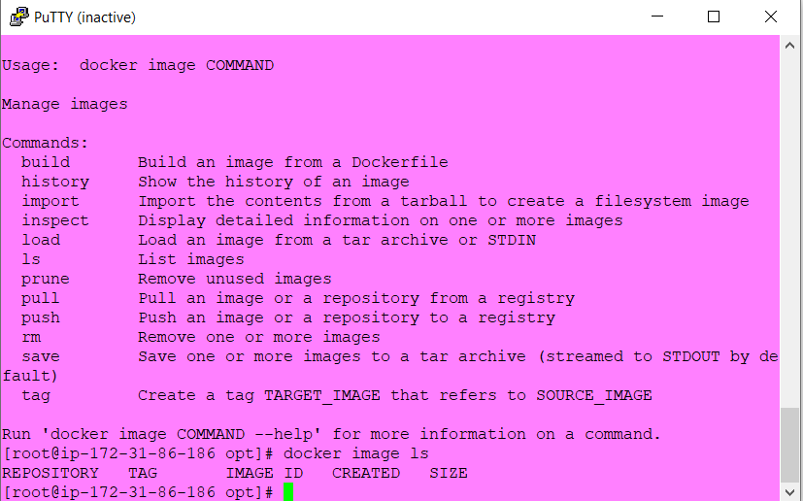

1. On Jenkins Server:
2. Install java

Yum install java

1. Install Jenkins

* **sudo wget -O /etc/yum.repos.d/jenkins.repo https://pkg.jenkins.io/redhat-stable/jenkins.repo**
* **sudo rpm --import https://pkg.jenkins.io/redhat-stable/jenkins.io.key**
* **yum install Jenkins**

1. **Run**

**systemctl starts jenkins**

**systemctl enable Jenkins**

1. **Copy Public IP from Jenkins server and paste it on url**

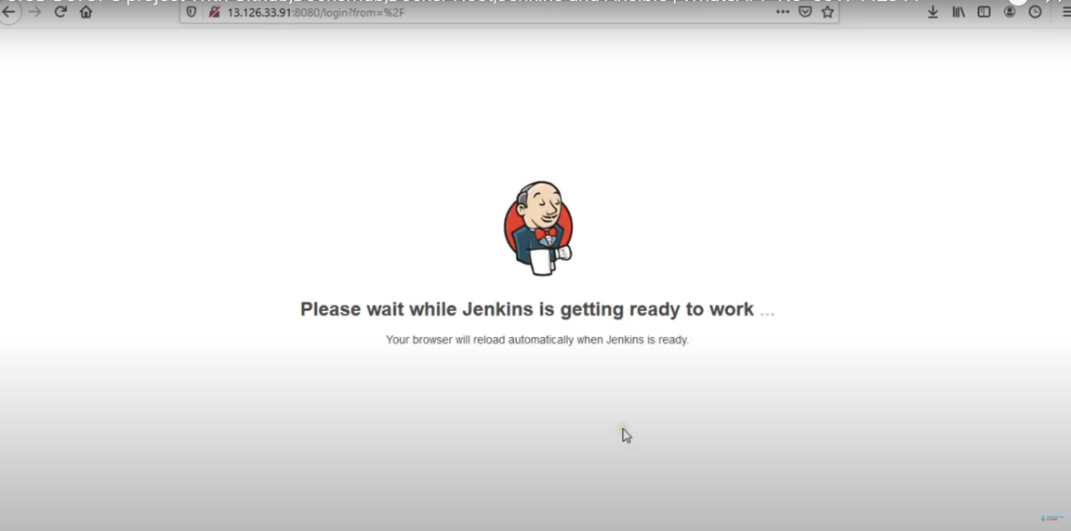

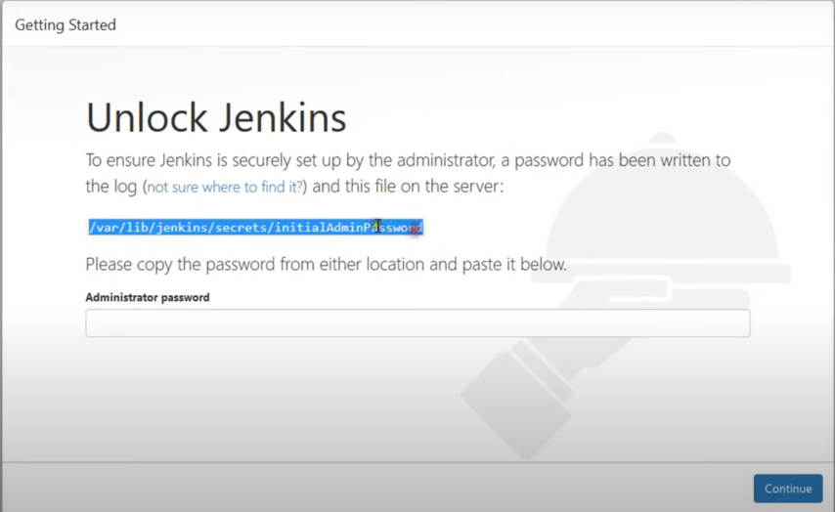

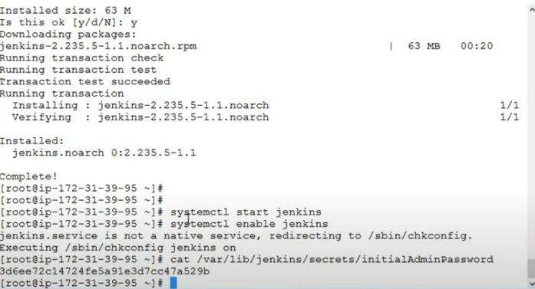

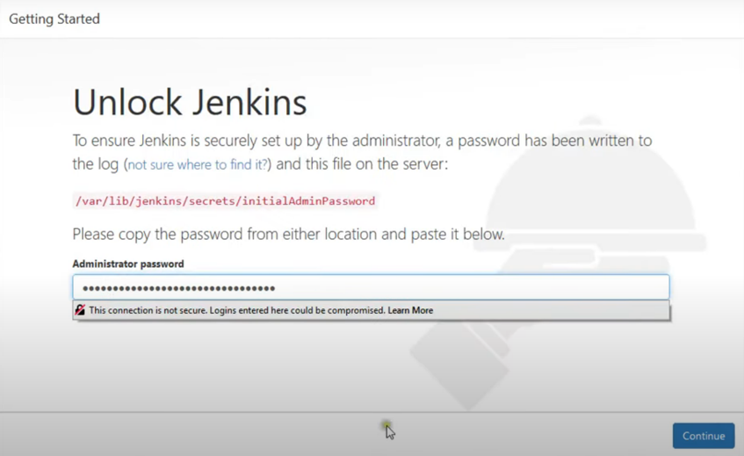

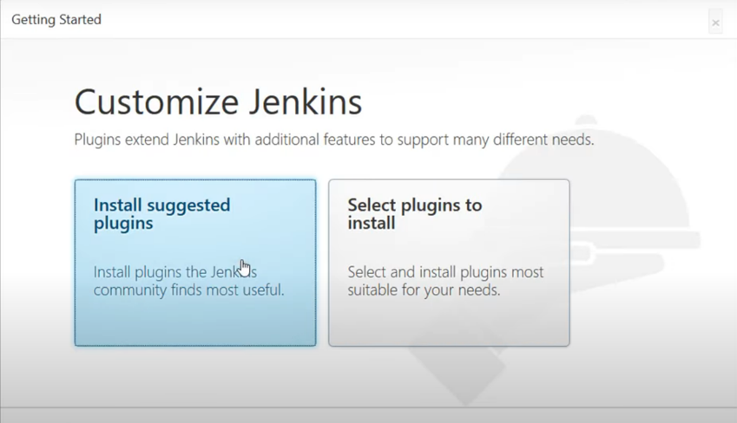

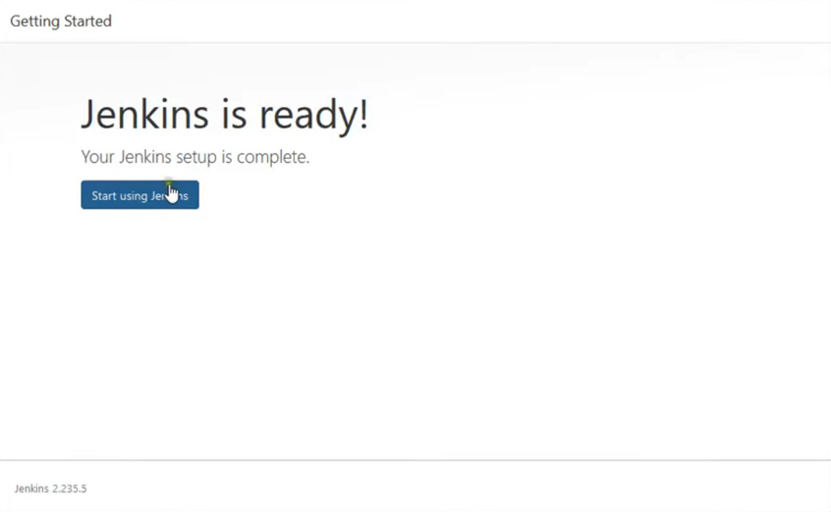

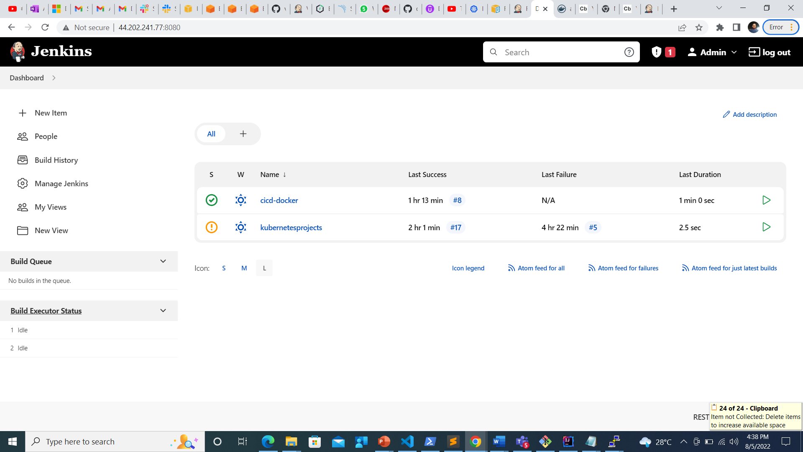

1. **Install Plugins: Publish Over SSH**

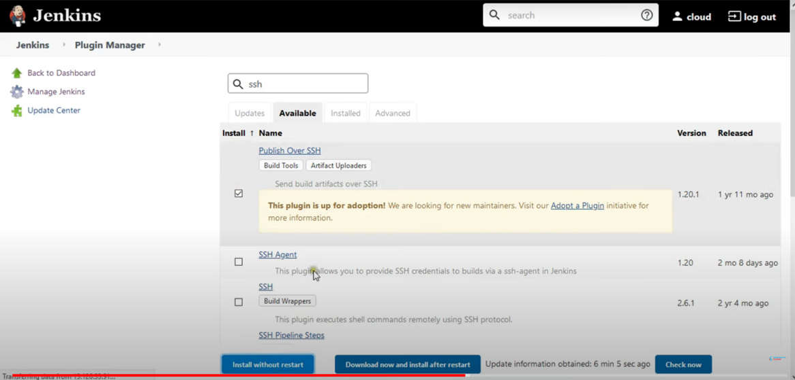

1. **Configure the System**

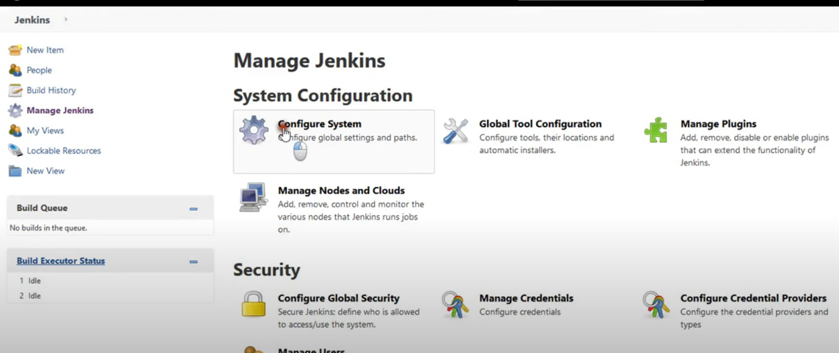

1. **Add SSH Server**

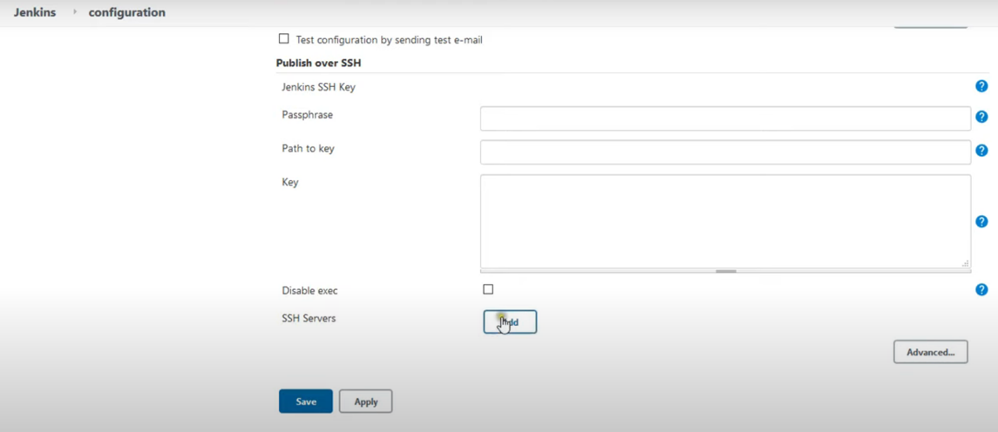

1. **Paste Private IP address of Jenkins Server and click on Use Password authentication or use a different key**

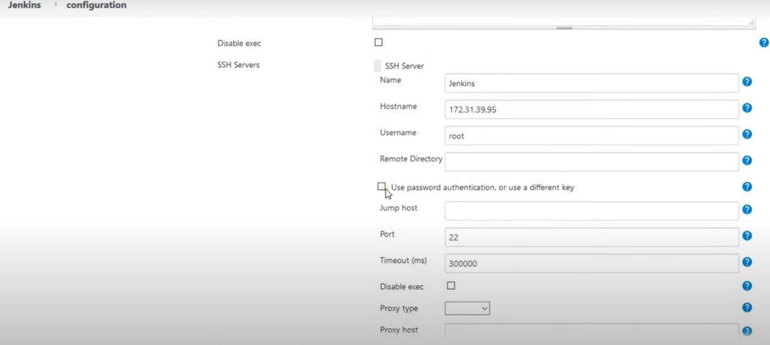

1. **Now Run: As per the following:**

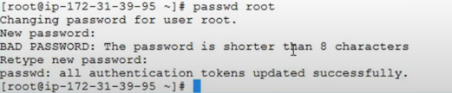

1. Run command:

vim /etc/ssh/sshd_config

1. Enable:

PermitRootLogin

Changed:

PasswordAuthentication from no to Yes.

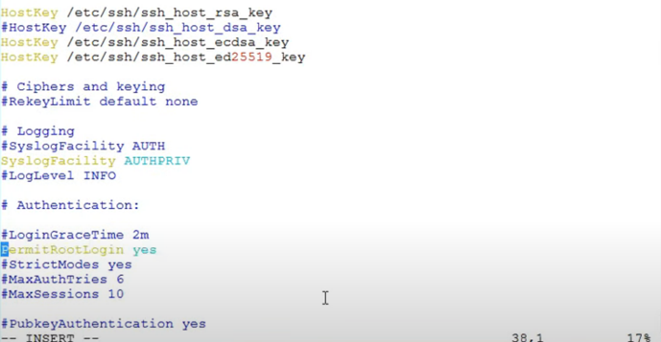

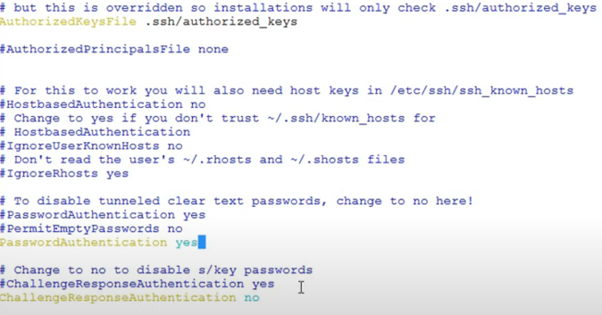

1. systemctl restart sshd
2. Give password as per step 16:

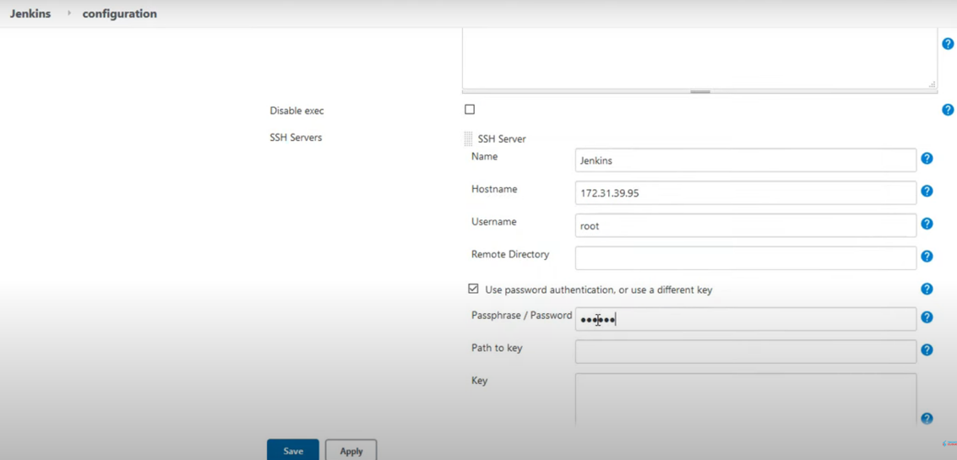

1. Add SSH Ansible Server

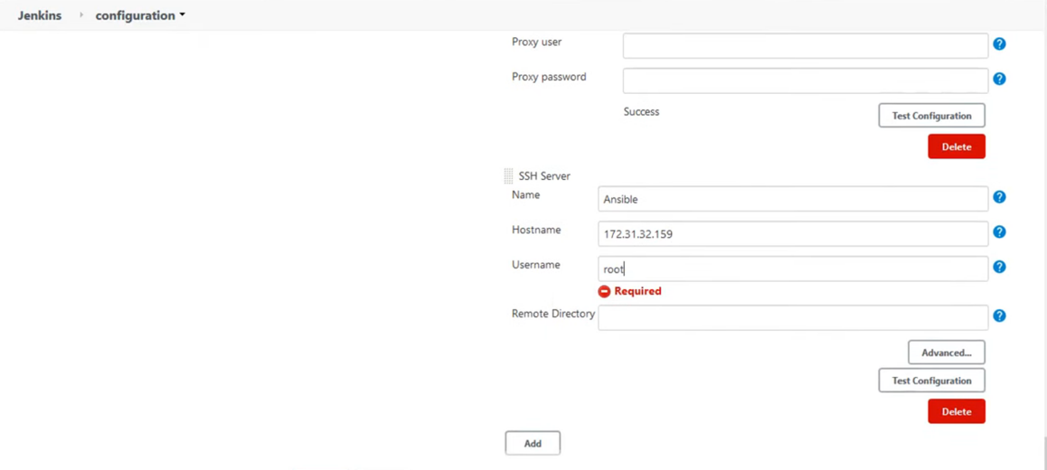

1. Now create a do the same process in Ansible Server as we did for Jenkins server(Step 17-20)

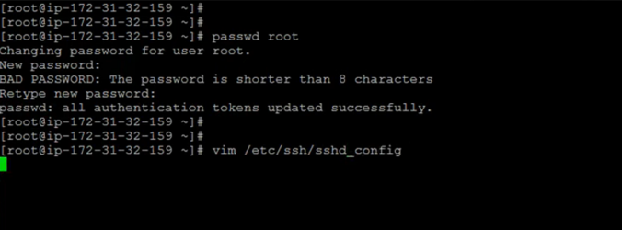

1. Give password in Ansible server:

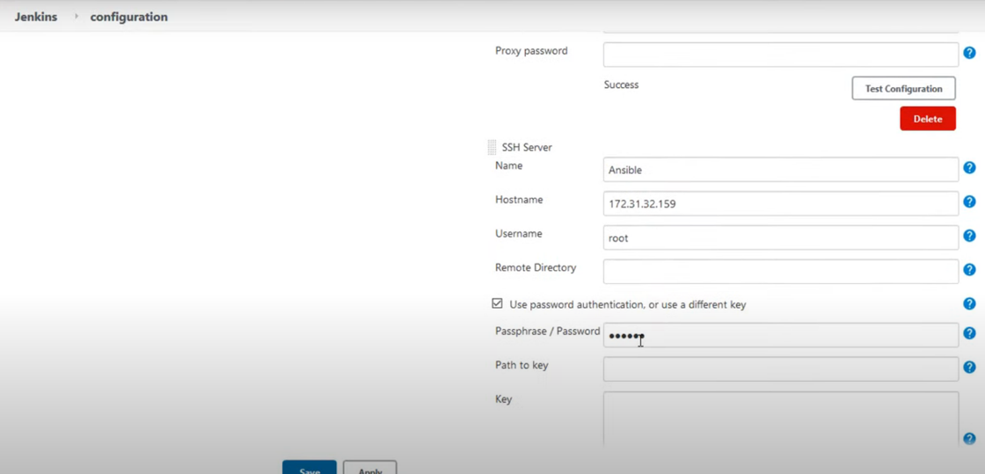

1. Save and apply after testing the servers
2. Now make a passwordless connection between controller-machine and Ansible server.

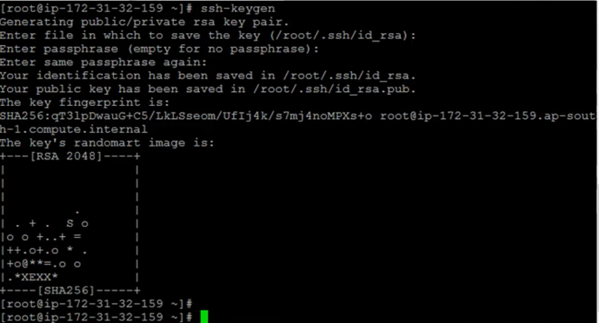

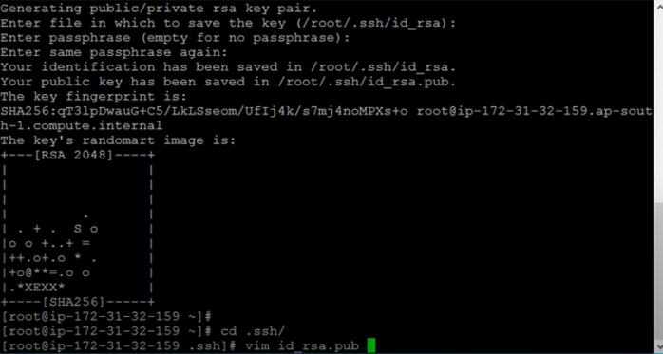

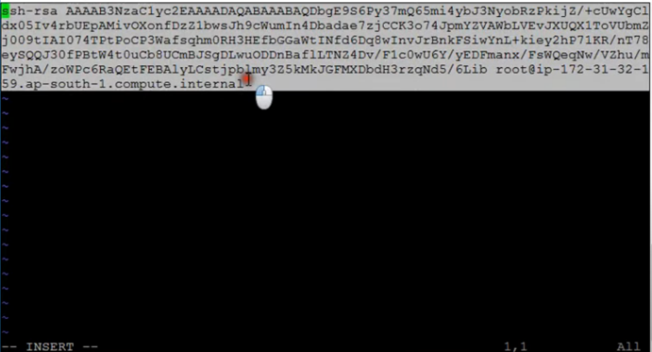

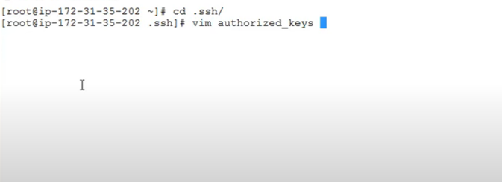

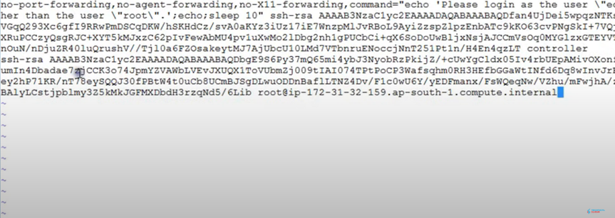

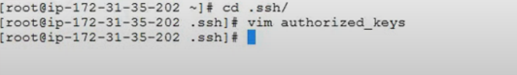

1. Now Check whether the connectionless connection is established:

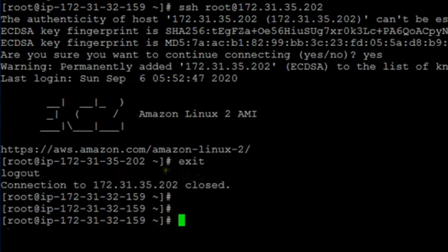

1. Install Docker on Ansible Machine



1. Start and enable Docker

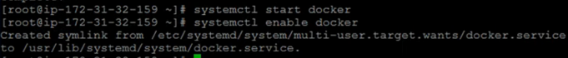

1. Now established the connectionless automatic connection between Ansible and Jenkins



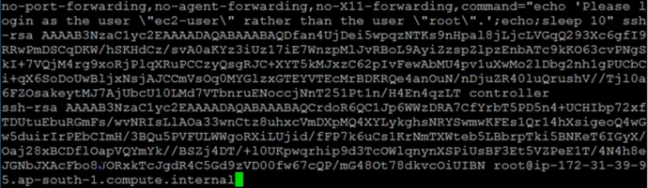

1. Check here serverless authentication done or not.

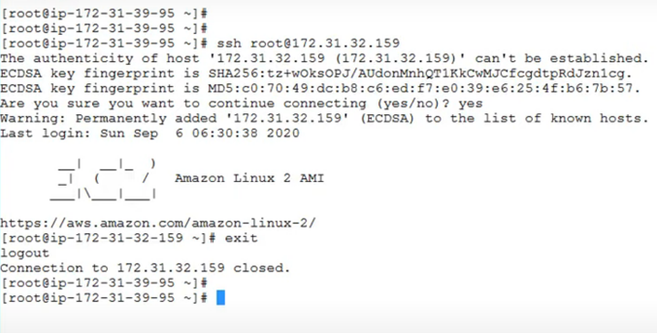

1. Login into Docker

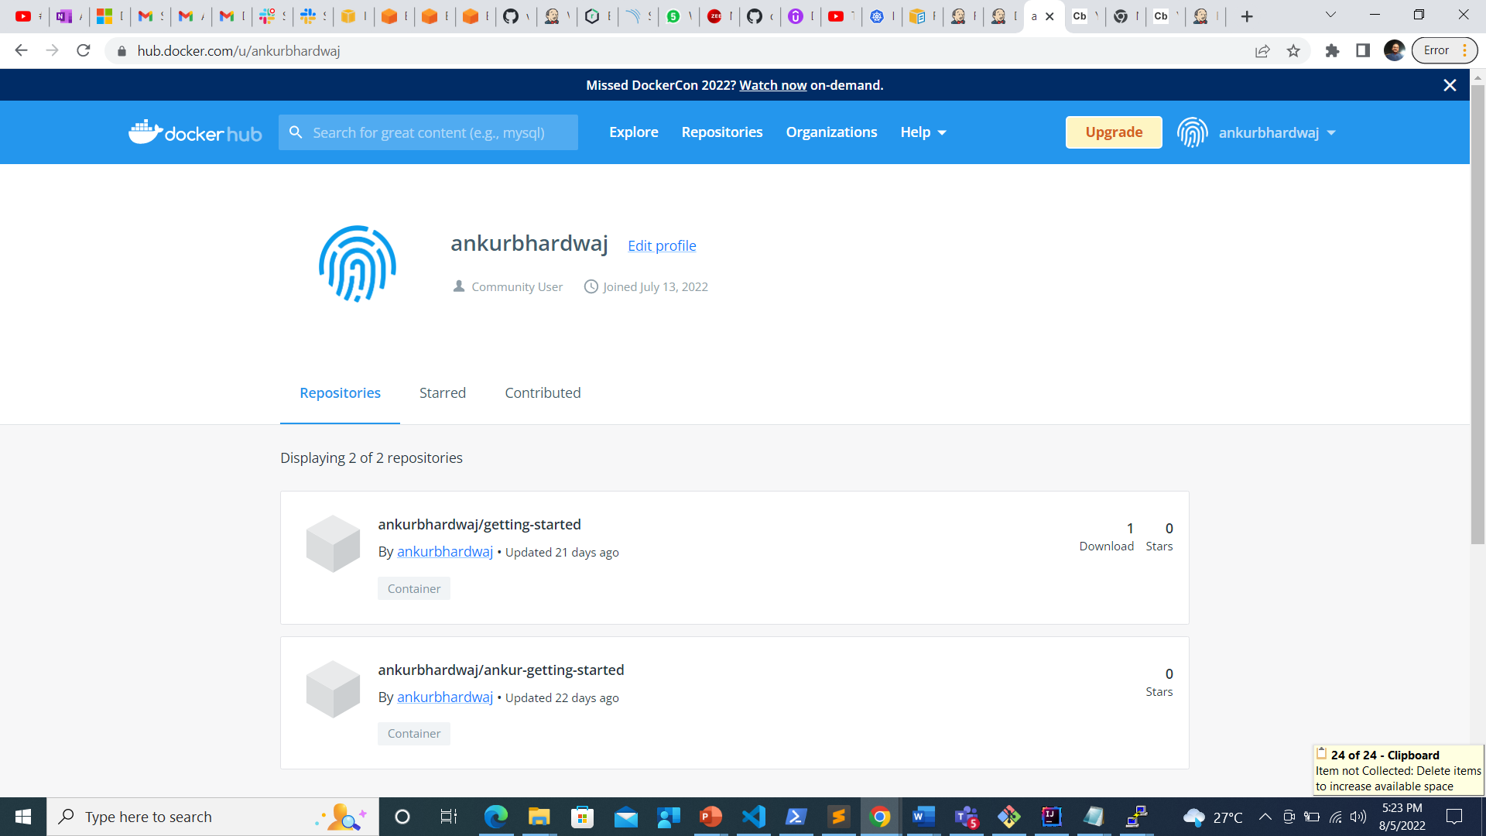

1. Login into docker on Ansible

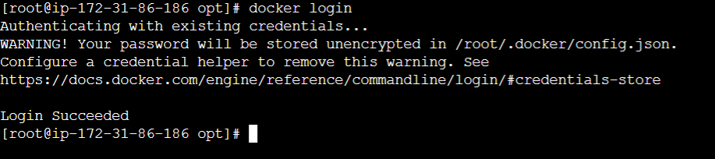

1. Install Ansible on Ansible server
2. Create Ansible Files

ansible.yml, deployment.yml, service.yml

**Ansible.yml**

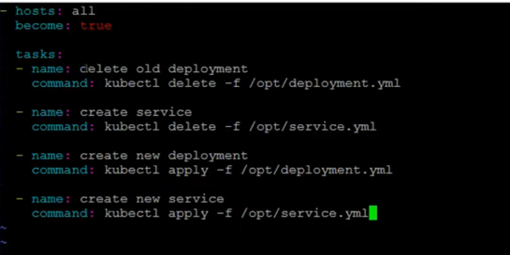

**Deployment.yml**

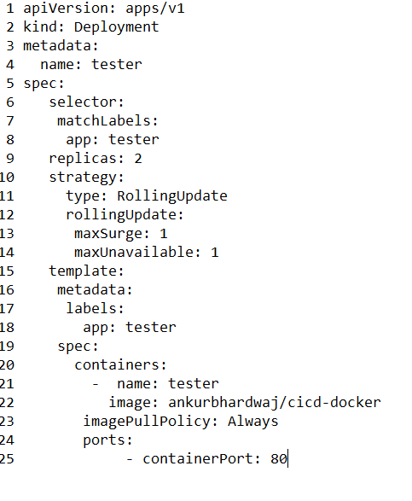

**Service.yml**

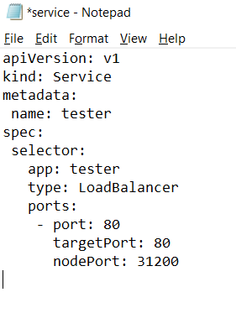

1. Create a repository on github account and create a docker file in it.

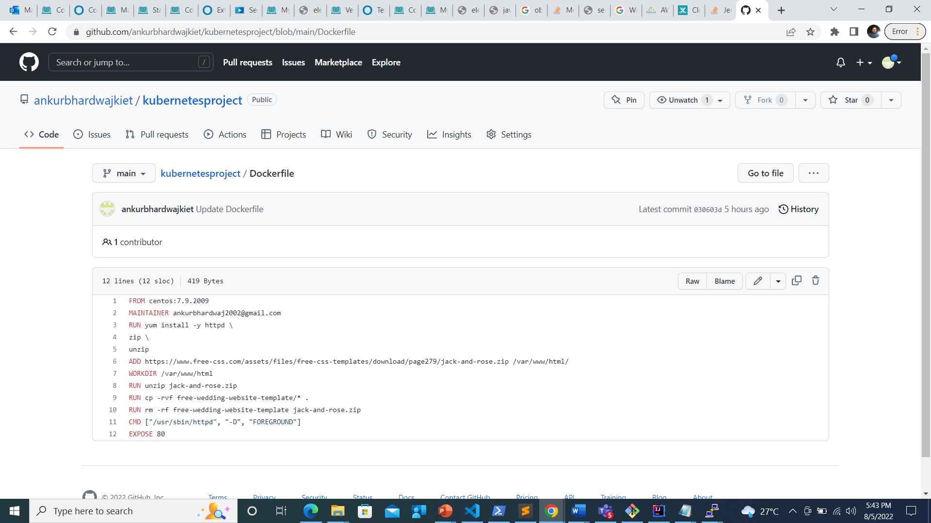

1. Established the connection with webhooks on github
2. 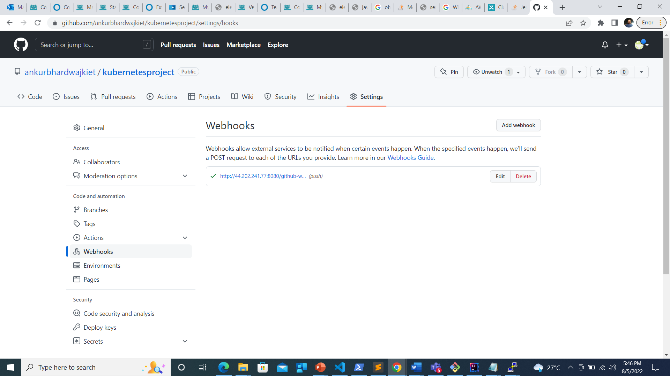
3. Build a job on Jenkins: as cicd-docker
4. Paste the link of the github repository
5. Install Git on jenkins
6. 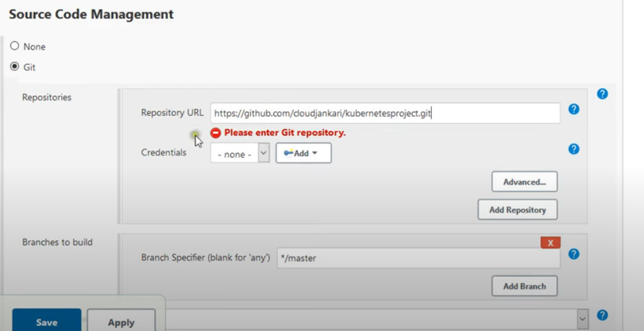
7. Send files or execute commands over SSH & Execute command as:

rsync -avh /var/lib/jenkins/workspace/cicd-docker/Dockerfile root@172.31.86.186:/opt

1. 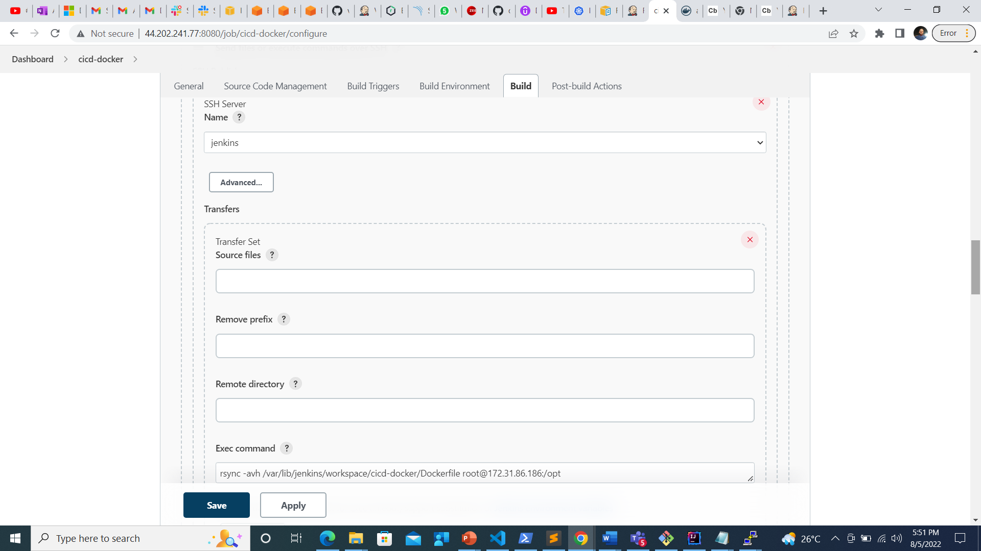
2. In Ansible server paste the docker file in exec command

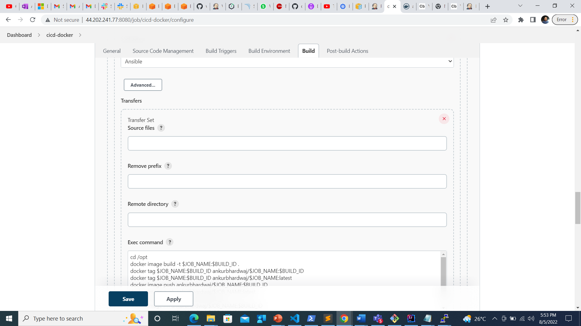

1. Post-build action:

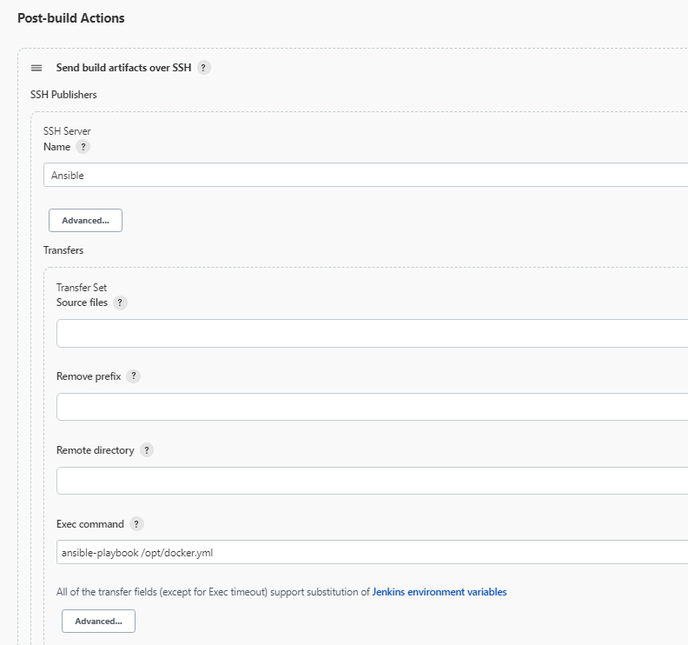

1. Build the Job

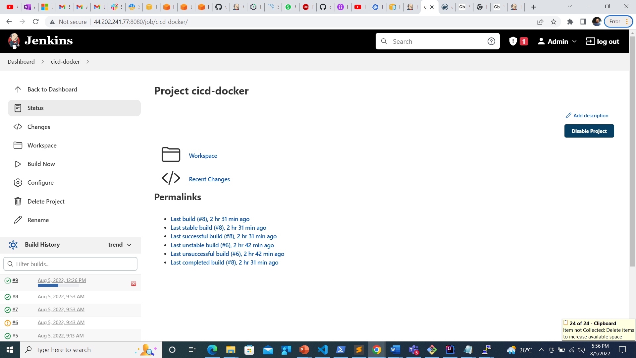

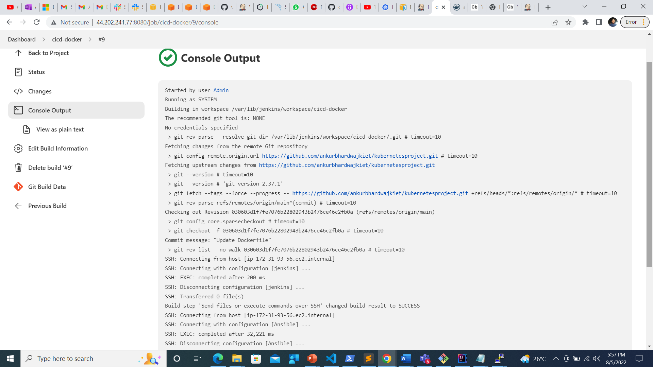

1. Run kubectl get nodes to find the port no. to login on url along with public IP of master
2. 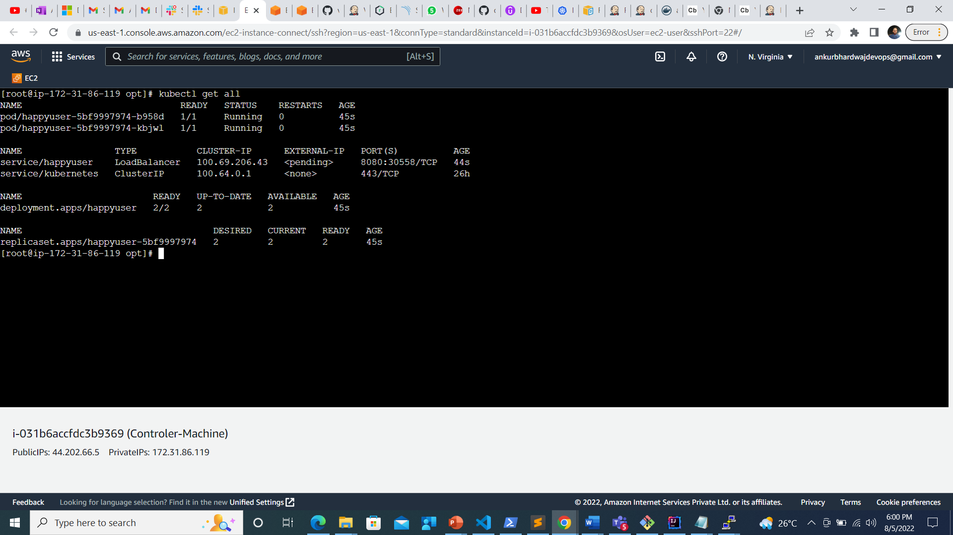



**Cloud Watch:**

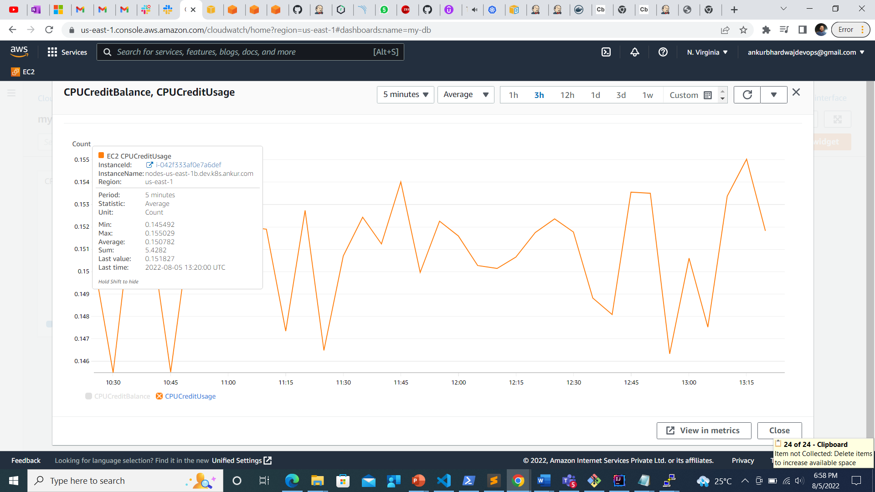

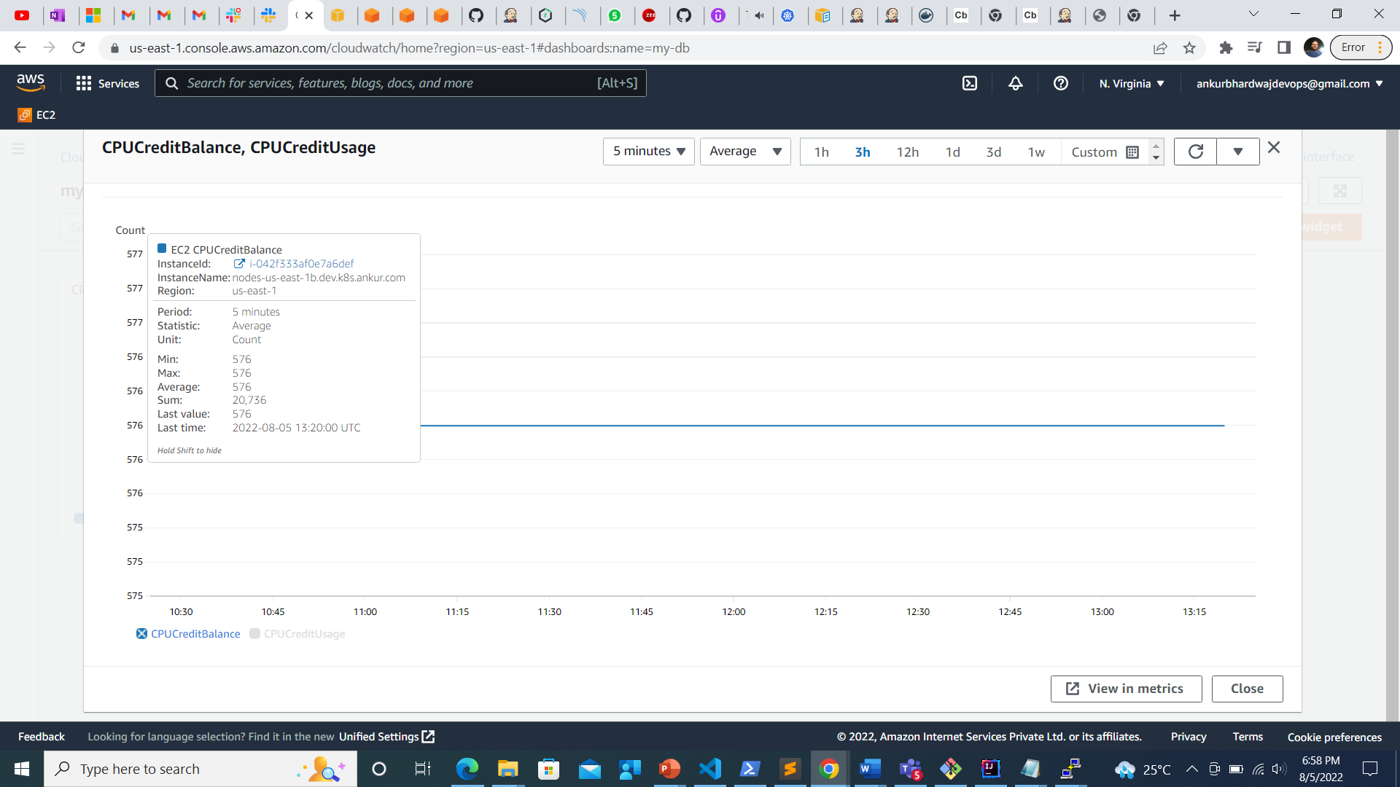

GITHUB Link:

https://github.com/ankurbhardwajkiet/kubernetesproject.git